PIMS 6585
INTEGRATED NATURAL RESOURCE MANAGEMENT IN VERY HUMID CLIMATIC REGIONS OF EASTERN BLACK SEA COASTAL REGION IN TURKIYE (DOKSAY) PROJECT

ANNUAL PROGRESS REPORT
1 Jan – 31 December 2025

Responsible Party Agreement
Contract Information
Responsible Party: | Nature Conservation Centre Foundation (DKM)
Project Number and Title: | PIMS 6585 : Integrated Natural Resource Management in Very Humid Climatic Regions of Eastern Black Sea Coastal Region in Türkiye
Implementation Period: | 01 November 2024 to 31 August 2027
Total Budget for RPA | 1.088.370 USD
Report Information
Annual Progress Report No: | 1 (2025)
Period covered by the report: | From 01/01/2025 to 31/12/2025
Annual Budget | $176.569,63
Submission date: | 29.12.2025
Uğur Zeydanlı acting as the Authorized Person of DKM confirm and certify that the information contained in this Quarterly Progress Report is correct and accurate to the best of my knowledge.
 | Name | Date | Signature
Prepared by: | Esra Kartal  Field Coordinator /Project Manager, DKM
Reviewed by: | Iraz Uran Özaltınlı  Project Associate, UNDP Türkiye
Approved by: | Meral Mungan Arda  Climate Change and Environment Portfolio Manager, UNDP Türkiye

Contents
Executive Summary 4
Background Information 5
Progress Review and Results 5
Project Progress 6
Contribution to Gender Equality 20
Monitoring Arrangements 20
Financial Status 21

LIST OF ACRONYMS
AFAD | Disaster and Emergency Management Presidency
CLC | CORINE Land Cover
ÇEM | General Directorate for Combating Desertification and Erosion
ÇAYKUR | General Directorate of Tea Enterprises
DEM | Digital Elevation Model
DKM | Nature Conservation Centre
DSM | Digital Surface Model
EBSC | Eastern Black Sea Coastal
ESMF | Environmental and Social Management Framework
GCPs | Ground Control Points
GEF | Global Environment Facility
GIS | Geographic Information System
GSA | Gender Sensitive Action
INRM | Integrated Natural Resources Management
LDN | Land Degradation Neutrality
MODIS | Moderate Resolution Imaging Spectroradiometer
MoEUCC | Ministry of Environment, Urbanization and Climate Change
NGO | Non-Governmental Organizations
NPP | Net Primary Productivity
OGM | General Directorate of Forestry
SLM | Sustainable Land Management
SOC | Soil Organic Carbon
3D | Three-Dimensional
UASIS | National Land Cover Classification and Monitoring System
UNDP | United Nations Development Program

Executive Summary
This report has been prepared in line with the Responsible Party Agreement and the Communication, Knowledge Management, and Outreach Plan developed within the scope of the “Integrated Natural Resource Management (DOKSAY) Project in Türkiye’s Eastern Black Sea Coastal Region under Very Humid Climate Conditions.” The report contains information on the activities carried out or initiated during the four quarters of 2025 and the budget allocated for these activities.
Within this scope, the following activities were carried out:
- Act 1.1.1. - Bilateral meetings and planning activities were conducted with stakeholders and the GDNC (ÇEM) for the establishment of the inter-agency panel.
- Act 1 1.2 - Drafting of a mission statement, a basic code of conduct, and terms of reference for the inter-agency panel has been revised based on the feedback from the senior management of GDNC (ÇEM).
- Act 1.1.3. the membership list and terms of reference for the Council of Land and Disaster Management Experts and Practitioners have been prepared.
- Act 1.1.4. During the planning process of the activity, a series of bilateral meetings were held.
- Act 1.1.5. The preparations for organizing the data obtained through official correspondence and for creating the database were carried out by the Climate Expert.
- Act 1.2.1./1.2.2./1.2.3./1.2.4./1.2.5. - Data collection continued as a fundamental step in the preparation of the INRM plan.
- Act 1.2.6 - Field studies have begun (landslide inventory, biodiversity monitoring, research on traditional land use and gender.
- Act 1.3.1. - Bilateral meetings were held with ÇEM senior management and stakeholders on agriculture, forestry, ecosystem services, and biodiversity.
- Act 1.3.2. - Interviews were conducted with women living in the project area and with a women’s cooperative to carry out an assessment of disadvantaged groups.
- Act 1.3.3. - A workshop was held to determine criteria and indicators for sustainable tea cultivation. Preliminary assessments were conducted with institutions to determine criteria and indicators for sustainable forestry.
- Act 1.3.4 – In order to reach an agreement on both issue-based and site-based recommendations for INRM, the workshop programs for December were prepared and implemented (Workshop on the Identification of Indicators and Criteria for Sustainable Tea Cultivation & Workshop on Sustainable Land Management and Ecosystem Services Mapping).
- Act 1.3.5. - A service procurement has been carried out.
- Act 2.1.1. - In order to identify sustainable land use practices, preparations for a document based on field studies, institutional consultations, and literature reviews have been initiated.
- Act 2.3.1./2.3.2./2.3.3./2.3.6. - Work has been initiated to identify training activities aimed at enhancing the capacities of forest managers, local farmers, and farmer associations for Sustainable Land Management (SLM).
- Act 2.4.1. - Opinions of institutions and experts have been obtained.
- Act 3.1.2. - The website and social media accounts has been finalized and launched. The project logo has been finalized. The design and production of visibility materials have been completed (presentation templates, roll-ups, notebooks, tote bags, name badge and pens). Three training booklet and one brochure on the project and LDN have been prepared.
- Act 3.1.4. - The Communication, Information Management, and Promotion Plan has been prepared and implemented.
- Act 4.1.1. – The Inception Workshop has been completed.
- Act 4.1.2. /4.1.3. - The data collection process is being carried out.
- Act 4.1.4. - Efforts have been made to implement the six activities within the scope of the gender mainstreaming action plan.

The activities carried out, along with the service procurement and monitoring-evaluation activities, were implemented in accordance with UNDP Türkiye’s quality assurance and monitoring-evaluation requirements. In addition, the implementation processes of the activities were assessed through meetings between ÇEM and DKM.

Background Information
The project aims to develop institutional and technical capacities for integrated natural resource management (INRM) in Türkiye's Eastern Black Sea Coastal Region. In line with this objective, the project seeks to enhance the capacity of local stakeholders by applying sustainable land management (SLM) techniques, contribute to land degradation neutrality (LDN) efforts, promote sustainable land use models, and strengthen ecosystem resilience. The project is being implemented in the Kireçhane Micro-Basin, affiliated with Salarha Municipality in Rize, and spans a 36-month period from 2024 to 2027.

Progress Review and Results
Signing of Responsible Party Agreement: The Responsible Party Agreement was signed between DKM and UNDP Türkiye on 31 October 2024. Updated multi-year workplan, annual workplan and procurement plan were submitted to UNDP.
Hiring of Contractual Staff: The recruitment of contract staff for the project was announced on 9 January 2025. A two-stage interview process was conducted with applicants by DKM. The results of the preliminary evaluation conducted by DKM were submitted to UNDP and ÇEM for their consent. Following this process, on 17 March 2025, a Field Officer (Soner Oruç) to be assigned to Rize and a Field Coordinator/ Project Manager (Fatma Esra Kartal) to be assigned to Ankara were hired by DKM, following the establishment of cash flow on 7 February 2025. The relevant personnel were introduced during a visit to the office of the General Director of ÇEM.
In addition to above the Project Coordinator is assigned by ÇEM as Ms. Sibel Nihal Tekin.
Procurement of IT Equipment: 3 computers and one hard disk are procured for the utilization of the project implementation unit, namely Field Coordinator/Project Manager (DKM), Field Officer (DKM) and Project Financial and Administrative Associate (UNDP), also including the completed administrative procedures for the transfer of equipment.
Constituting of Project Board: As per the Project Document, the Project Board is comprised of the General Directorate for Combating Desertification and Erosion, UNDP Türkiye, the Presidency of Strategy and Budget, and the Ministry of Foreign Affairs as natural members. The preparatory work for the Project Board meeting, initiated in the first quarter, was completed in the third quarter, and the meeting was held on the date jointly determined by ÇEM and UNDP Türkiye. The first Project Steering Committee meeting was held on 22 July 2025 at the General Directorate of Combating Desertification and Erosion (ÇEM). The Steering Committee has approved the project’s budget and activity plan for 2025. It has been decided that the next meeting will be held in January 2026.
Inception Workshop: The Inception Workshop was organized on April 15, 2025 to raise awareness among stakeholders about the project's objectives and to determine the individual roles and responsibilities of stakeholders in the project planning, implementation and monitoring processes. The Inception Workshop Report was approved on 4 July 2025, following the revisions deemed necessary in line with the evaluation processes.

Project Progress
Component 1: Integrated natural resource management planning in landscapes with very humid climate
Output 1.1: An inter-agency panel on SLM for the Rize Province is established to coordinate the efforts on SLM among relevant stakeholder organizations
Activity 1.1.1 Organize bilateral meetings and visits to the local governor’s office and key sector entities in Rize Province to review existing gaps and constraints for management of land issues (From 2025-Q1 to 2025-Q3)
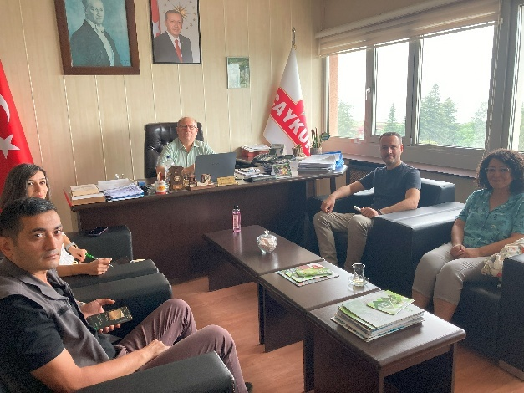
Status: Completed
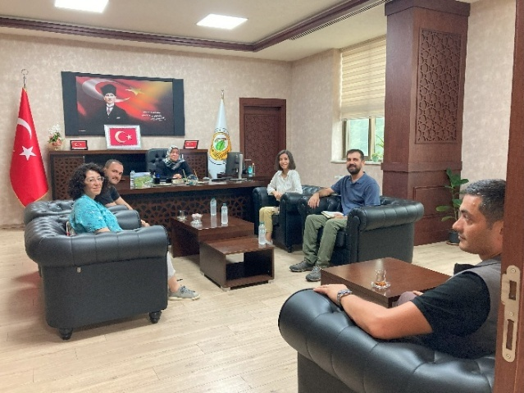
Within the scope of the activity, a series of bilateral meetings were held between ÇEM and DKM to determine the methodology. In parallel, visits were made to 12 institutions planned to take part in the panel, and information was provided about the purpose of the panel. Meetings were held with the Deputy Governor of Rize and the Governor of Rize with the aim of establishing the panel under the chairmanship of the Governor. Finally, at the meeting held with the Governor of Rize on 22 December, it was decided to establish the ınter-agency panel under the chairmanship of the Rize Governorate, and the Rize Provincial Directorate of Environment, Urbanization and Climate Change was officially assigned to carry out the secretariat of the panel.
Activity 1.1.2.: Draft and secure stakeholder agreement on a mission statement, a basic code-of-conduct, and terms of reference for the commission. (From 2025-Q1 to 2025-Q3)
Status: Ongoing
A mission statement, a basic code of conduct, and terms of reference for the commission have been prepared, taking into account the assessments of ÇEM senior management. In the subsequent process, these document may be revised and further developed based on the views of the Rize Governor’s Office.
Activity 1.1.3. Establish a Council of Land and Disaster Management experts and practitioners to support the INRM planning (From 2025-Q2 to 2026-Q1)
Status: Ongoing
In addition to Q3-2025;
Within the scope of Activity 1.1.2, the membership list and terms of reference for the Council of Land and Disaster Management Experts and Practitioners have been prepared. Care was taken to ensure the inclusion of representatives from public institutions, universities, and non-governmental organizations (NGOs). In the next quarter of the project, the Provincial Directorate will conduct the official correspondence with the relevant institutions and carry out the preparations for the first meeting.
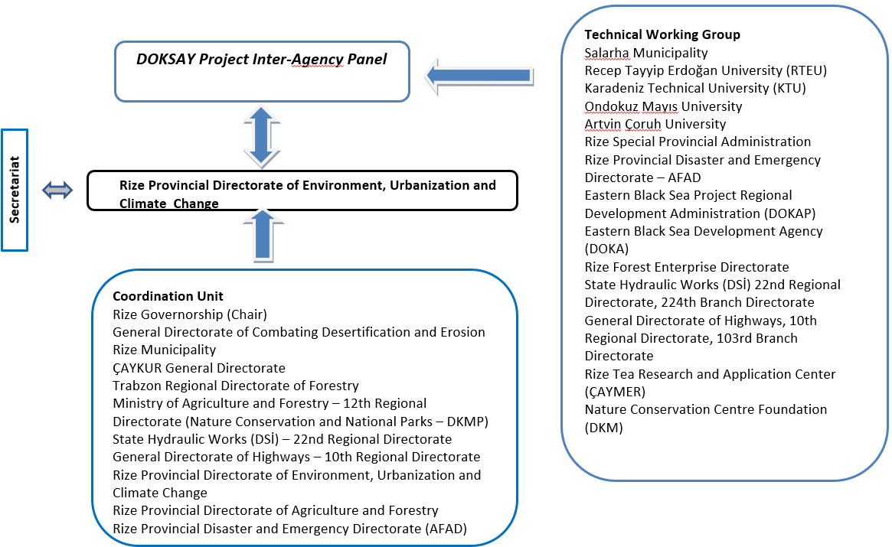
Table 1: Organizational Chart

Activity 1.1.4: Reach agreement on the role of the project in supporting the implementation of national LDN targets (From 2025-Q2 to 2025-Q4)
Status: Ongoing
During the planning process of the activity, a series of bilateral meetings were held. Within the scope of these meetings, it was decided to hold a preliminary planning meeting, primarily with the participation of ÇEM experts working on the subject.

Activity 1.1.5. Hold structured and moderated meetings for the entire project duration to carry out the commission’s role of overseeing the preparation of a detailed GIS-based database for the Kireçhane micro-basin. (From 2025-Q2 to 2027-Q3)
Status: Ongoing
The preparations for organizing the data obtained through official correspondence and for creating the database were carried out by the Climate Expert.

Activity 1.1.6. Lead efforts to ensure dissemination of the project’s messages and results within key agencies and stakeholder groups. (From 2026-Q4 to 2027-Q3)
Status: To be initiated

Activity 1.1.7. Initiate negotiations with governors of all provinces covered by the EBSC Region to expand the inter-agency SLM Commission to cover the entire EBSC Region (From 2025-Q4 to 2026-Q3)
Status: To be initiated

Output 1.2: Evidence-based documentation of the degree of land degradation, main drivers of land degradation including the ones related to climate change, and the effect on the lowlands of floods caused by land degradation.
Activity 1.2.1: Collect data and carry out detailed assessments for the pilot Kireçhane micro-basin
(From 2025-Q2 to 2025-Q4)
Status: Ongoing

Sustainable agriculture, sustainable forestry and climate experts were hired in May 2025.

A framework (outline) for the INRM Plan, a list of data required for the preparation of the plan, and an evidence-based documentation study were prepared by the experts and submitted to ÇEM. Following the evaluations, official letters requesting data were sent by ÇEM to the relevant institutions. With the data obtained, the area-specific assessment process has been initiated, and reminders have been sent to institutions that have not responded to the official requests.

Within the scope of the required data list prepared by the experts, the Field Officer conducted field studies to identify breeding and migratory bird species in the Kireçhane micro-watershed. One of the identified species, the Black Woodpecker (Dryocopus martius), is classified as “Near Threatened” for Türkiye (Annex 6). In addition, the website of the Turkish Statistical Institute (TURKSTAT) was reviewed, and some publicly available socio-economic data (gender distribution, education level, population data) were obtained.

Within the scope of the publication review conducted for the project site, in addition to scientific literature, research reports published by institutions such as the Rize Chamber of Commerce, DOKA, and DOKAP were also reviewed.

In addition, in order to support future GIS-based spatial analyses to be carried out by the General Directorate for Combating Desertification and Erosion (ÇEM), a high-resolution Digital Elevation Model (DEM) and a three-dimensional solid terrain model of the Kireçhane micro-basin have been produced. For this purpose, a drone-based aerial survey was conducted.

A detailed field survey was conducted by ÇEM experts in the Taşlıdere sub-basin, including the Kireçhane pilot site. This study aimed to assess and model future landslide potential by focusing on the development of a systematic inventory of past landslide events. The inventory has begun to be developed through the combined use of remote sensing interpretation and field validation techniques. The collected landslide data will be used to generate landslide susceptibility maps by integrating geological, topographic, hydrological, and land cover parameters through statistical and data-driven modeling approaches. Within this scope, the first draft of the landslide inventory has been prepared, and ÇEM’s work on this subject is ongoing.

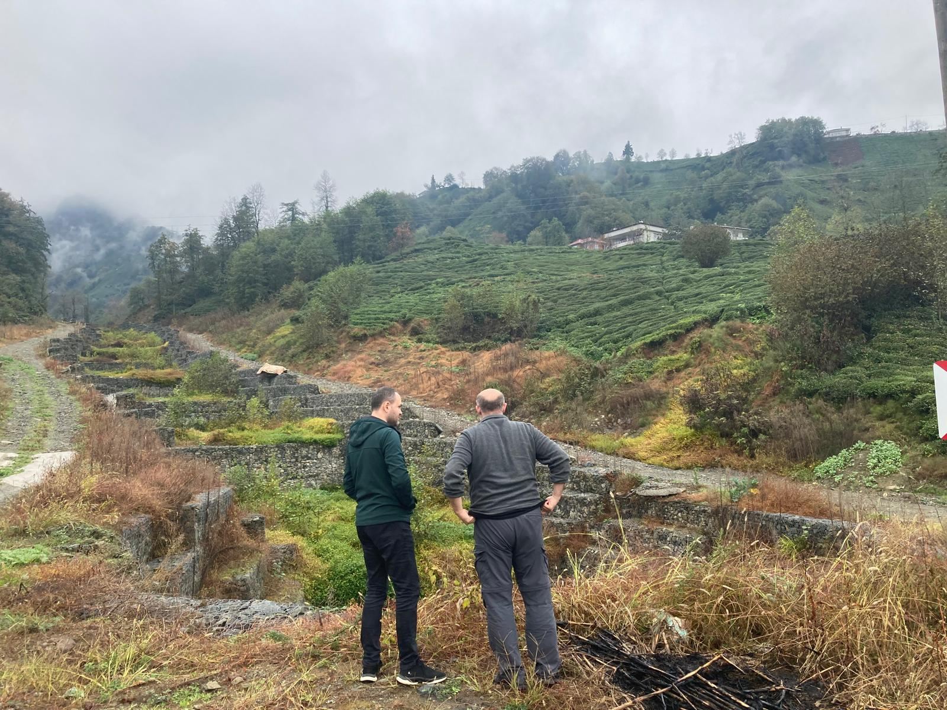

The Field Officer continued field visits in the third quarter to identify tea gardens, houses, and roads in Kireçhane Neighborhood that were affected by landslides and are at risk. Within the scope of these activities, 11 priority areas were identified in Kireçhane Neighborhood, mapped, and shared in the form of a report for evaluation by ÇEM experts and senior management. On 15 November, the identified areas were examined on site with the participation of Kürşat Özcan from ÇEM and the Sustainable Forestry Expert, and as a result, 5 areas were designated as priorities for rehabilitation works.

Activity 1.2.2. Using participatory sketching and mapping techniques, illustrate ecosystem services
(From 2025-Q3 to 2026-Q1)
Status: Ongoing
In addition to Q3-2025;

A series of bilateral meetings were held with the Head of the Ecosystem Services Department of the Trabzon Regional Directorate of Forestry, the Regional Director, the Deputy Regional Director, the General Directorate of Forestry – Department of Ecosystem Services, and the Rize Forest Enterprise Directorate. In order to identify Sustainable Land Management (SLM) practices for Rize province and to map ecosystem services using a participatory approach, a workshop was organized on 22–23 December.

The distribution of workshop participants by day and gender is as follows:
-On 22 December, a total of 50 participants attended the workshop, including 14 women and 36 men.
-On 23 December, a total of 48 participants participated, including 13 women and 35 men.

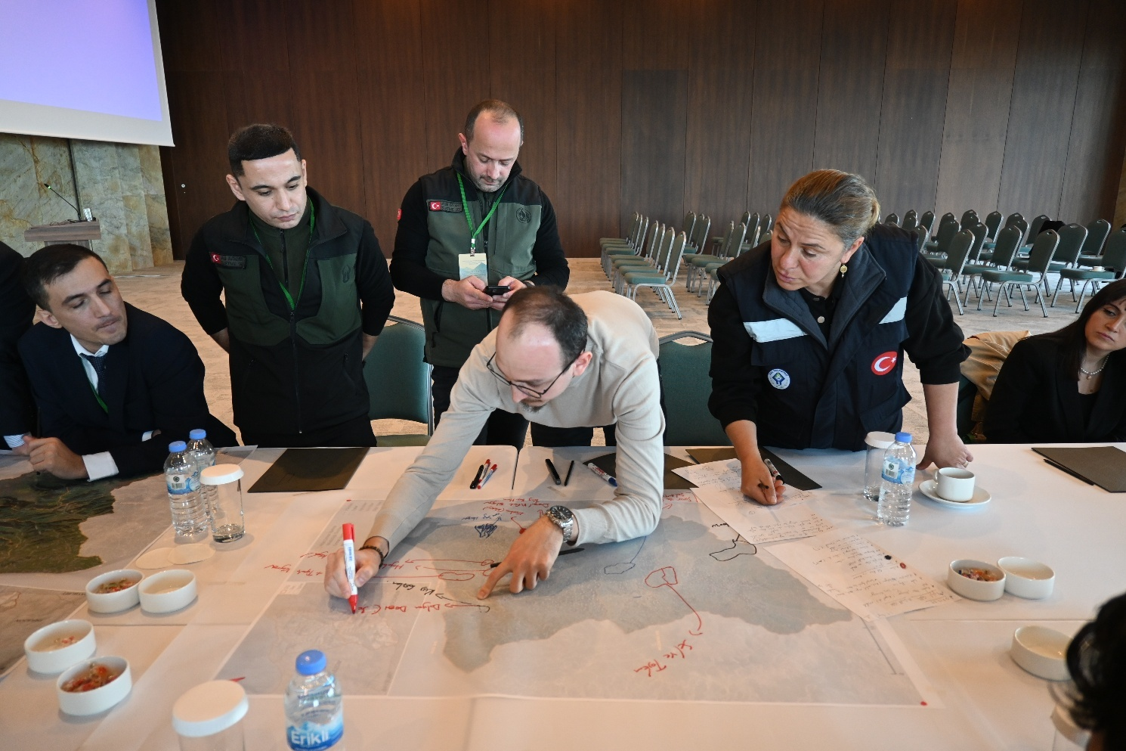

Through this workshop, ecosystem services were identified under four main categories: provisioning services, regulating services, supporting services, and cultural services. Within the scope of the workshop, three training manuals prepared on Land Degradation Neutrality (LDN), Sustainable Land Management (SLM), and Forest Ecosystem Services were presented to the participants as training materials.

Activity 1.2.3. Produce spatial climate projections as new layers (From 2025-Q3 to 2026-Q1)
Status: Ongoing
All the data required for this activity could not be obtained; therefore, the work has not been completed. It is planned to finalize the activity in the upcoming period of the project.

Activity 1.2.4. Superimpose existing information on flood sensitivity; former landslide, rock-fall incidents and impacts (From 2025-Q3 to 2026-Q2)
Status: Ongoing
The work carried out in the region by AFAD and ÇEM, as well as the data they possess, have been compiled. In the next phase of the project, the relevant maps and assessments will be completed within the scope of the activity.

Activity 1.2.5. Conduct vulnerability assessment by means of a weighted vulnerability analysis
(From 2025-Q3 to 2026-Q2)
Status: Ongoing
ÇEM carried out landslide inventory update studies for the Taşlıdere Basin. The first draft of the inventory was prepared and presented to the participants within the scope of the workshop held on 22 December. It is planned to complete this work in the following months of the project.

Activity 1.2.6 Document and validate the methodology and analytical tools applied to the assessment undertaken in Kireçhane micro-basin (From 2025-Q3 to 2026-Q2)
Ongoing
In order to verify the collected data and the implementation methods planned based on these data on site, institutional and field visits were carried out by the Sustainable Agriculture Specialist on 14–15 October, and by the Sustainable Forestry Specialist on 14–15 November. ÇEM experts conducted fieldwork between 4–8 August to verify existing data on site within the scope of the landslide inventory study.

Output 1.3: A gender sensitive INRM Plan prepared for a pilot micro-basin covering an area of 430 ha that is based on SLM and LDN principles.
Activity 1.3.1 Consultations with agriculture, forestry and biodiversity/ecosystem services experts through bilateral meetings, focus groups (From 2025-Q2 to 2025-Q4)
Status: Ongoing

Meetings were held with ÇEM senior management to conduct evaluations for each quarter of the project.

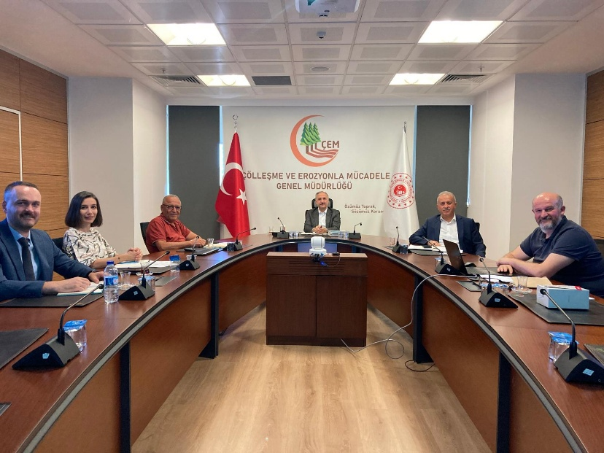

With the participation of the Project Coordinator (ÇEM), Sustainable Agriculture Expert and the Sustainable Forestry Expert, institutional visits were carried out in Rize, during which discussions were held on agriculture, forestry, biodiversity, and ecosystem services. During these meetings, the views of stakeholder institutions were gathered regarding the planning process of activities related to these topics.

Activity 1.3.2. Evaluate the involvement of disadvantaged groups (such as the elderly, youth, and women) in natural resources management at the micro-basin level (From 2025-Q3 to 2026-Q1)
Status: Ongoing
A survey was conducted with 13 women aged between 36 and 82 in Kireçhane neighborhood.
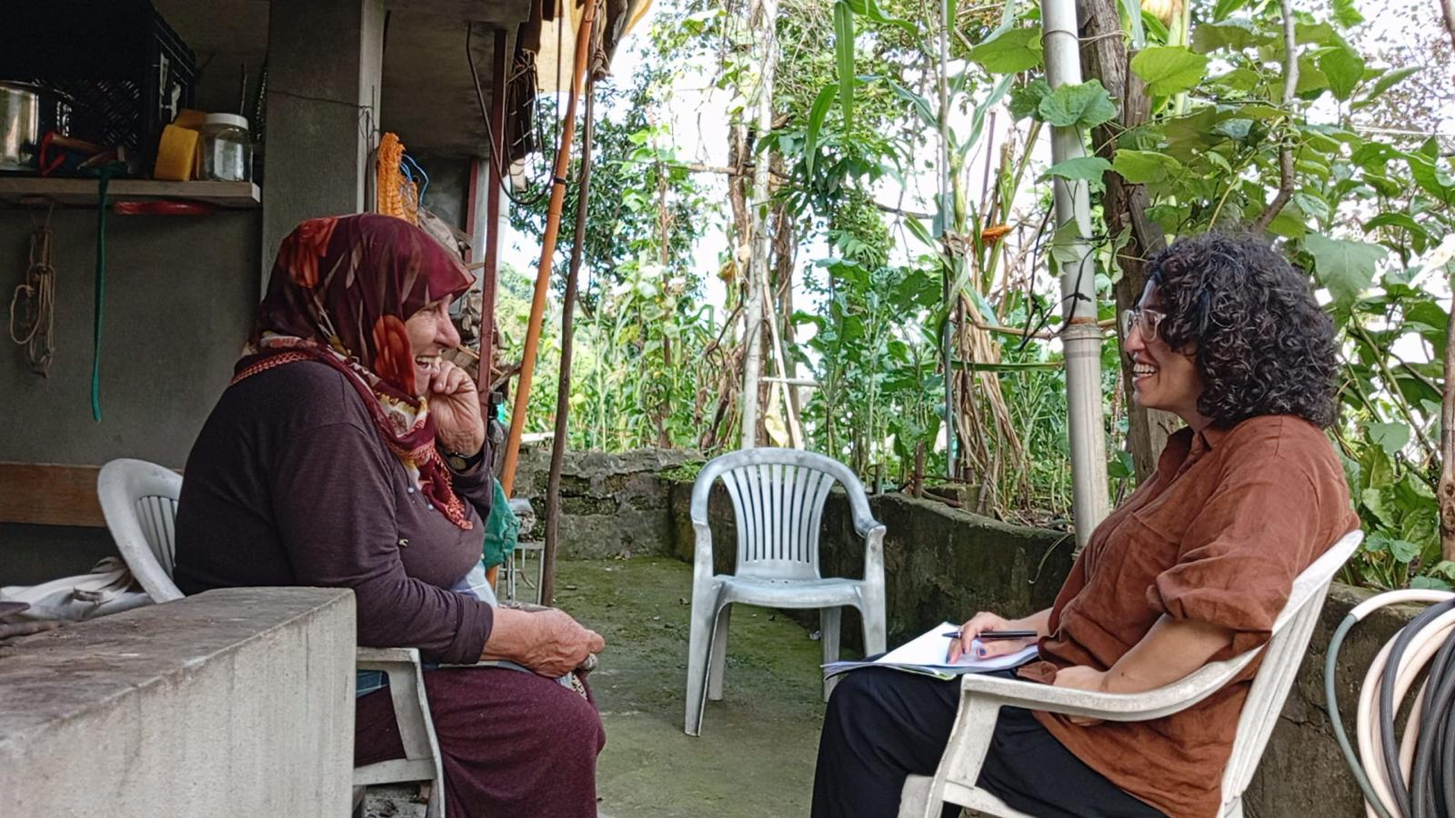

The Kaçkar’ın Etekleri Women’s Entrepreneurship and Production Cooperative was visited and informed about the project. Within the scope of this meeting, information was also obtained regarding the cooperative’s activities and the challenges encountered in carrying out these activities. Possible areas of collaboration will be evaluated in detail.

Activity 1.3.3. Identify key elements (practices, indicators, criteria) for sustainable forest management and sustainable tea production that promote SLM (From 2025-Q3 to 2026-Q1)
Status: Ongoing
In terms of identifying key elements related to sustainable forestry, the “Criteria and Indicators for Sustainable Forest Management” prepared by the General Directorate of Forestry at the national level have been identified as a fundamental resource, and the necessary collaborations to be established within this framework have been evaluated. Meetings and workshops will be organized with institutions in Rize to assess these national criteria and indicators at the provincial scale.

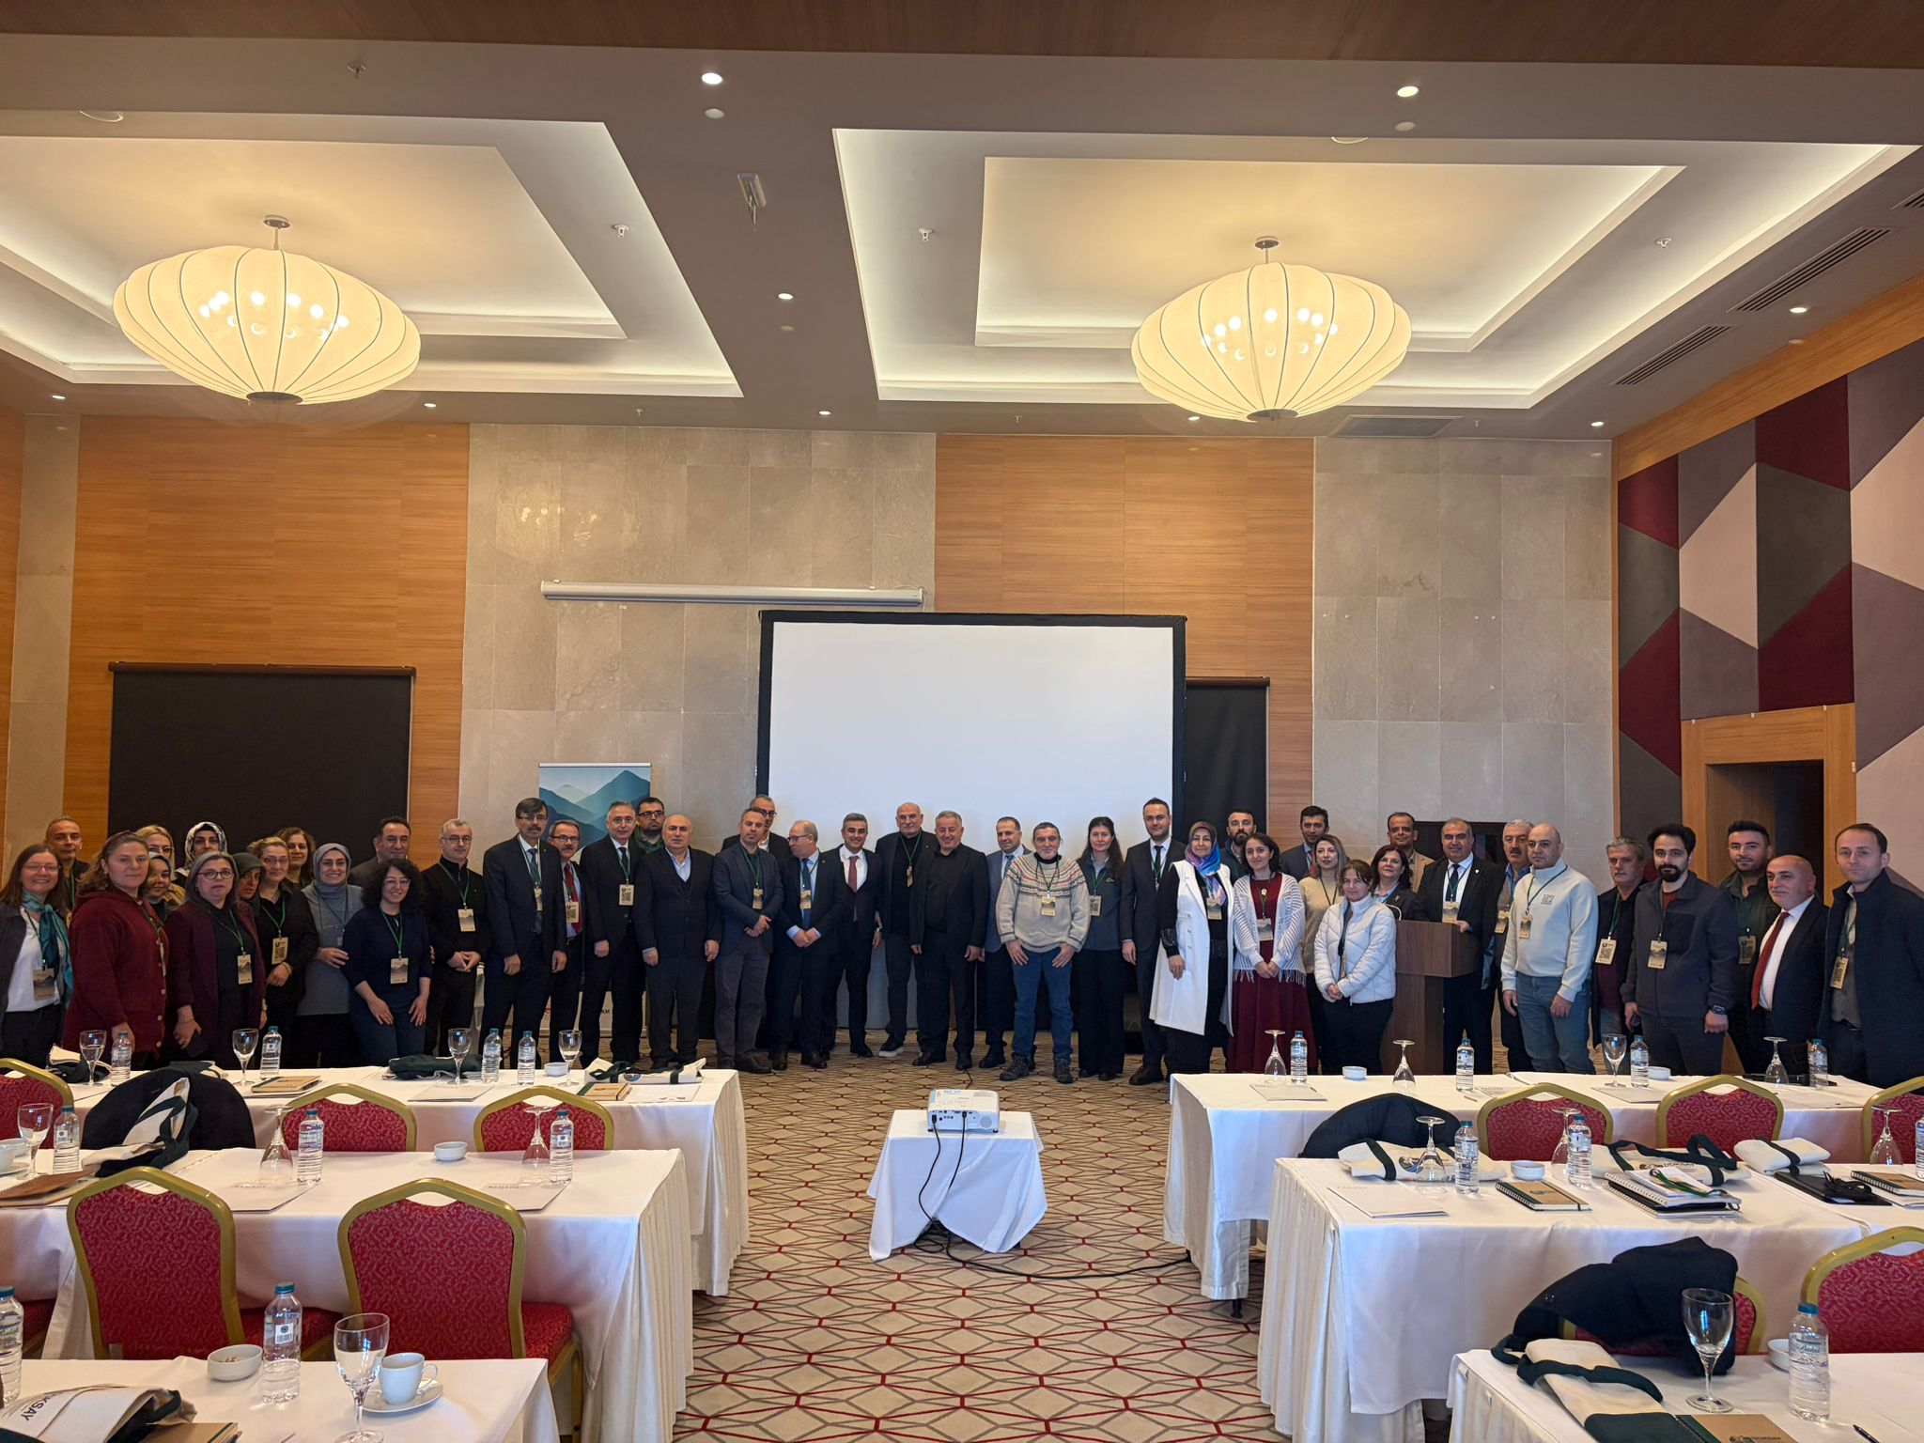

Literature reviews to identify the key elements of sustainable agriculture have continued, and the drafted indicators (physical, agricultural, social, economic) have been revised. The work on determining the indicators and criteria has been carried out under the coordination of the Sustainable Agriculture Expert. In this context, a workshop was held on 16 December 2025 in Rize, with the participation of civil society organizations, universities, the private sector, and public institutions. The workshop was attended by 52 participants (20 women and 32 men).

Activity 1.3.4. Agree on both issue-based and site-based recommendations for INRM and illustrate these on the maps (From 2025-Q4 to 2026-Q2)
Status: Ongoing

The workshops listed below, along with their dates, were held as scheduled. The information gathered during these workshops will be incorporated into the maps in the next phase of the project.
- Workshop on the Identification of Indicators and Criteria for Sustainable Tea Cultivation, 16 December 2025, Rize
- Workshop on Sustainable Land Management and Ecosystem Services Mapping, 22-23 December 2025, Rize

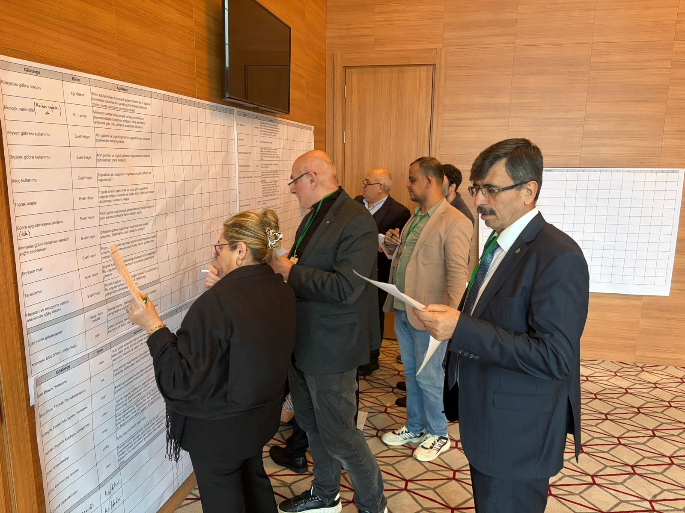

Activity 1.3.5. Develop an INRM Plan for the Kireçhane micro-basin that seeks to balance at a landscape scale (for the pilot micro-basin) economic, social, gender, cultural and environmental objectives
(From 2025-Q4 to 2026-Q3)
Status: Ongoing

The service procurement for the preparation of the background studies for the Integrated Natural Resource Management Plan has been completed in accordance with the Terms of Reference prepared within the project and the applicable procurement procedures.

Output 1.4: Identification of policy and legislative measures legislation that are needed to support implementation of the INRM Plans in humid climatic zones.
Activity 1.4.1. A rapid legislative gap analysis and review of policies for land governance, land-use planning, and natural resource conservation and management(From 2025-Q4 to 2026-Q2)
Status: Ongoing
Within the scope of this activity, a meetings were held with the ÇEM Project Coordinator. Based on ÇEM's experience in this area, a roadmap for revising the existing information was discussed within the scope of the project.

Activity 1.4.2. Identify the gaps and opportunities in legislation and policies to implement SLM related activities as reflected in INRM Plan(From 2026-Q1 to 2026-Q3)
Status: To be initiated

Activity 1.4.3. Prepare a report, based on outcome of Activities 1.4.1 and 1.4.2 to identify revisions that might be required in the longer-term to provide an effective policy and legislative framework for implementation of INRM plans (From 2026-Q2 to 2026-Q4)
Status: To be initiated

Component 2: Land-based SLM practices in landscapes with very humid climate.
Output 2.1. Traditional land use practices for croplands homestead areas that cause reduced harm to soil are identified with a specific focus on women farmers and women-led households.
Activity 2.1.1. The identification and documentation of traditional sustainable land use practices(From 2025-Q3 to 2026-Q3)
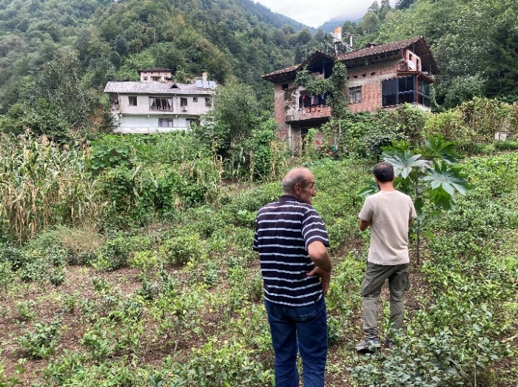
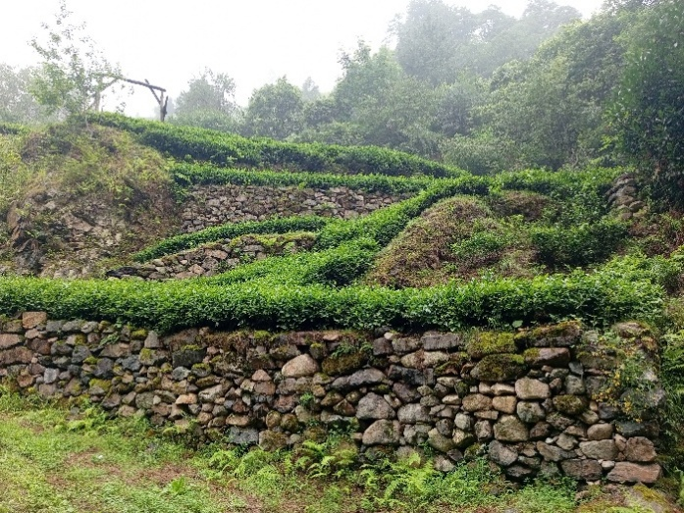
Status: Ongoing

In order to identify sustainable land use practices, efforts have been undertaken to prepare a document covering traditional sustainable land use practices and activities that can be implemented for soil conservation, based on field studies, institutional consultations, and literature reviews. This work is planned to be completed in the first half of the next quarter and submitted for review by ÇEM experts.

Activity 2.1.2. Production of a manual on traditional sustainable land-use implementation practices with recommended SLM practices for the EBSC Region (From 2026-Q1 to 2026-Q3)
Status: To be initiated
Activity 2.1.3. Manual and media communications will be shared with local land users
(From 2026-Q2 to 2027-Q3)
Status: To be initiated
Activity 2.1.4. To raise the visibility and promote further replication of these traditional best practices, region-wide contests held (From 2026-Q2 to 2027-Q3)
Status: To be initiated
Output 2.2. SLM practices for forests and agricultural lands implemented in pilot micro-basin site
Activity 2.2.1. Joint mapping and selection of all the best cost-effective implementation methods and tools based on natural materials and methods that Türkiye and countries with very humid climate have implemented. (From 2026-Q1 to 2026-Q3)
Status: To be initiated
Activity 2.2.2 Identification of best practice priority SLM activities for promotion in the micro-basin, the project will support the following priority measures (From 2026-Q2 to 2027-Q3)
Status: To be initiated
Output 2.3. Training activities and peer to peer knowledge sharing activities promoted to enhance the capacities of forest managers, local farmers and farmer associations to promote SLM.
Activity 2.3.1. Conduct a capacity needs assessment (From 2025-Q3 to 2026-Q1)
Status: Ongoing
In order to identify the capacity-building needs of institutions, meetings were held with 11 institutions in Rize—including ÇAYKUR, the Trabzon Regional Directorate of Forestry, and the General Directorate of Forestry, as well as public institutions, local administrations, and a university—together with primary and secondary schools in the project area (9 schools) and the Kaçkar’ın Etekleri Women’s Entrepreneurship and Production Cooperative. Based on these consultations, the content plans for the workshops and trainings carried out in the fourth quarter of the project were developed.

Activity 2.3.2. Identify key agencies and institutions such as the Regional Forest Management Directorates, ÇAYKUR, ÇEM and others that can organize training activities for selected leading/pioneering farmers on a full package of sustainable production methods (From 2025-Q3 to 2026-Q2)
Status: Ongoing
Based on the meetings held with the General Directorate of Forestry and the Trabzon Regional Directorate of Forestry, it was identified that there is a need for an interactive training program on climate change, biodiversity, and ecosystem services for forest district units in the Eastern Black Sea Region. Within this scope, a training program was prepared and reviewed with the relevant institutions, and it was decided that the training would be implemented in the next quarter of the project.

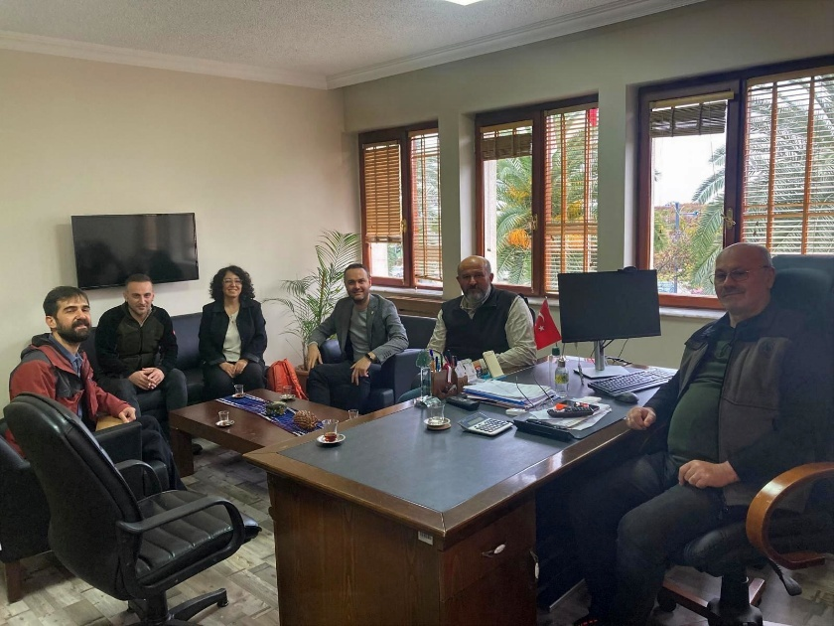
Within the scope of the evaluation carried out with ÇEM, it was decided that a training on landslide inventory preparation would be organized by ÇEM for staff from AFAD and the Provincial Directorate of Environment, Urbanization and Climate Change in Rize, as well as personnel from the regional directorates to which these institutions are affiliated. It was also agreed that this training would be organized and implemented by ÇEM, in cooperation with DKM, in the next phase of the project.

Based on the evaluation conducted with ÇAYKUR, it was assessed that the training program prepared for farmers could be implemented jointly with ÇAYKUR. However, in order to determine the scope of such cooperation, it was decided to conduct a pilot training at ÇAYKUR’s factory in Salarha with the participation of ÇAYKUR officials, and to evaluate the possibility of joint implementation based on the outcomes of this pilot.

Activity 2.3.3. Support key institutions (listed in Activity 2.3.2 and others) to build their capacity and be able to conduct training sessions for local decision-maker (From 2025-Q4 to 2027-Q3)
Status: Ongoing
Assessments conducted within the scope of Activity 2.3.1 revealed that the institutions consulted were not sufficiently familiar with the Land Degradation Neutrality (LDN) approach and its hierarchy. For this purpose, the agenda of the Sustainable Land Management and Ecosystem Services Mapping Workshop held on 22–23 December was designed and implemented to also address this knowledge gap.

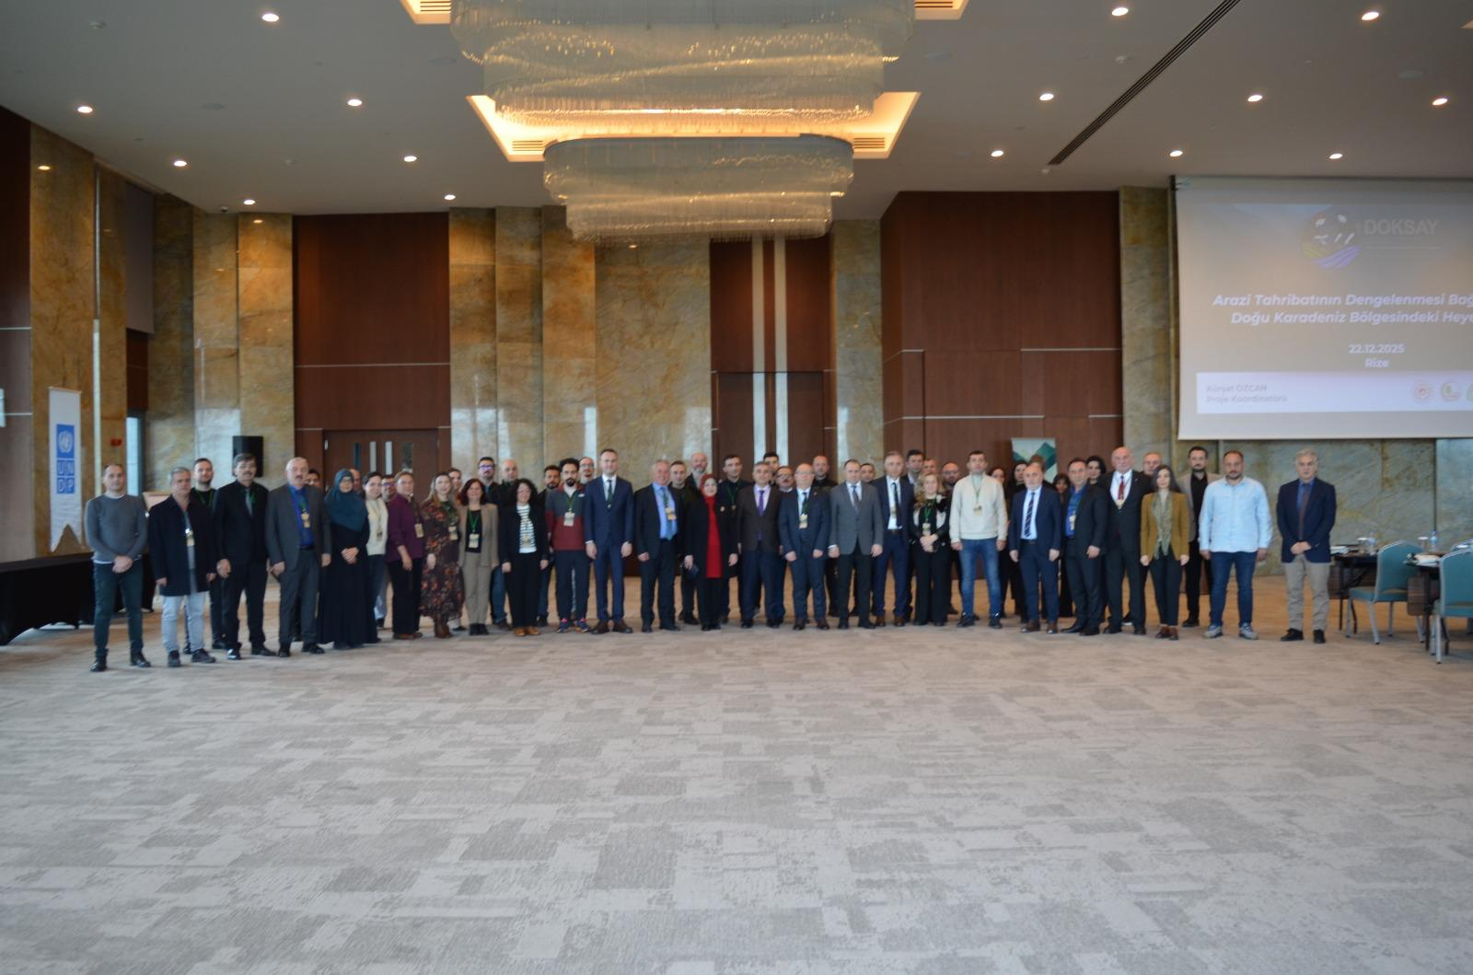

Within this framework, ÇEM project coordinators delivered informative presentations entitled Land Degradation Neutrality (LDN) Approach and Sustainable Land Management, Landslides in the Eastern Black Sea Region in the Context of Land Degradation Neutrality, and Sustainable Land Management Recommendations According to the LDN Intervention Hierarchy. Based on these briefings, participants worked collectively to identify sustainable land management approaches suitable for Rize.

In addition, in order to ensure that all institutions were informed about the activities of the Rize Forest Enterprise Directorate, a presentation was included in the program in which the Directorate introduced its ongoing work.

Activity 2.3.4. Organize meetings, field days, and visits to demonstration sites for tea farmers for hands-on learning about best-practice (From 2025-Q4 to 2027-Q3)
Status: To be initiated

Activity 2.3.5. Organize a study visit to a tea producing country/region with similar climate
(From 2026-Q1 to 2026-Q3)
Status: To be initiated

Activity 2.3.6. Undertake general awareness-raising activities about SLM practices to avoid/reduce/reverse land degradation (From 2025-Q4 to 2027-Q3)
Status: Ongoing
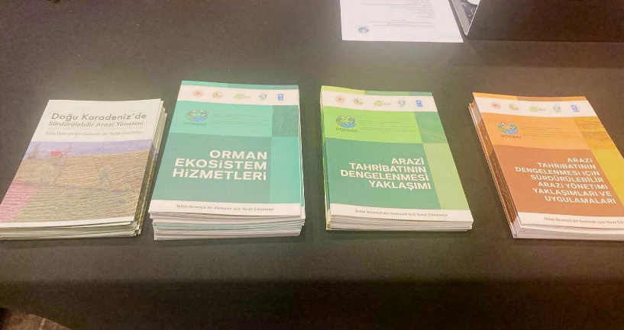
Three training manuals were prepared under the titles Land Degradation Neutrality Approach, Sustainable Land Management Approaches and Practices for Achieving Land Degradation Neutrality, and Forest Ecosystem Services. The Turkish versions of these publications were printed in 500 copies each and distributed to the participants of the workshop held on 22–23 December. In addition, English translations of the publications were prepared and published on the project’s website together with the Turkish versions. In addition to these publications, content development and preparation activities were carried out for three training manuals. It is planned to complete these publications in the next quarter of the project.

A project brochure was also prepared, printed in 1,000 copies.

Output 2.4. Resilience-building and income-generating models for sustainable value chains for the main products are identified and implemented
Activity 2.4.1. Review of on-going livelihood-based activities in the Rize Province to assess constraints, barriers and opportunities to promotion of enhanced value-chain opportunities
(From 2026-Q1 to 2026-Q3)
Status: Ongoing
Within the scope of consultations with institutions and experts, views were gathered on the constraints, barriers, and opportunities for enhancing value-chain opportunities in Rize. Some of these views include the Forest Management Directorate stating that it is carrying out pest control and chestnut planting activities to address pests adversely affecting the region’s gradually declining chestnut trees. Additionally, Prof. Dr. Turan Yüksek from Recep Tayyip Erdoğan University provided assessments on promoting aromatic plant cultivation to support the development of beekeeping and encouraging fruit cultivation.

A search has been initiated for experts from whom services can be procured to ensure the detailed implementation and completion of this activity.

Activity 2.4.2. Identify viable agri-food value chains that avoid and/or reduce land degradation, are also climate-resilient and gender-sensitive and contribute to green recovery (From 2026-Q2 to 2026-Q4)
Status: To be initiated

Activity 2.4.3. Based on the list of preselected value chains, mapping and analysis of value chains would be undertaken during early project implementation, including in-depth market and feasibility analysis.
(From 2026-Q3 to 2027-Q1)
Status: To be initiated

Activity 2.4.4. Establish or reestablish the tea plantations/other agri-product gardens as pilot bases with the support and technical knowledge from DOKAP, CAYKUR, FISKOBIRLIK, MOAF etc.
(From 2026-Q3 to 2027-Q3)
Status: To be initiated

Activity 2.4.5. Implementation: through capacity building, infrastructure development, market support, PPP and financing mechanisms (From 2026-Q3 to 2027-Q3)
Status: To be initiated

Activity 2.4.6. Explore the potential for alternative income generating activities (other than tea, hazelnut, in particular to further strengthen existing livelihood activities (From 2026-Q3 to 2027-Q3)
Status: To be initiated

Component 3: Knowledge management and replication
Output 3.1.: Knowledge management on SLM techniques for humid climate regions with steep topography promote learning and replication
Activity 3.1.1. Review, analyze, synthesize, and capture project lessons and experiences gained from pilot sites into different knowledge products (From 2026-Q4 to 2027-Q3)
Status: To be initiated

Activity 3.1.2. Design and maintain an online web page containing all the audiovisual and written knowledge products produced under the project ranging (From 2025-Q1 to 2027-Q3)
Status: Ongoing
In addition to Q3-2025;
The following activities have been carried out taking into account the Environmental and Social Management Framework (ESMF) and the final Communication, Information Management, and Promotion Plan;

- The website is completed: www.doksay.org
- In line with the discussions between ÇEM and DKM regarding the project's communication activities, Instagram and Facebook accounts have been created. Expert opinions from UNDP Türkiye communication specialists were sought regarding the visuals to be used on these social media platforms, and the accounts have been put into use.
- The project logo has been finalized with the input of ÇEM and UNDP Türkiye.
- The design and production of visibility materials have been completed (presentation templates, roll-ups, notebooks, tote bags, name badge and pens).
- Three training booklet and one brochure on the project and LDN have been prepared.

Activity 3.1.3. Organize a series of know-how sharing meetings in regions with similar climatic conditions and challenges to lay the groundwork for replication of project successes. (From 2025-Q4 to 2027-Q3)
Status: To be initiated

Activity 3.1.4. Design and carry out a communications and outreach plan to disseminate successful SLM approaches and practices (From 2025-Q1 to 2027-Q3)
Status: Ongoing
The Communication, Information Management, and Promotion Plan has been prepared.

The Project Field Officer participated as a speaker in a landslide-themed conference held at the project site on 7 May. During the event, a presentation was delivered to approximately 60 tea farmers, explaining the relationship between the project, landslides, and tea cultivation, and showcasing examples of sustainable tea farming practices from around the world.

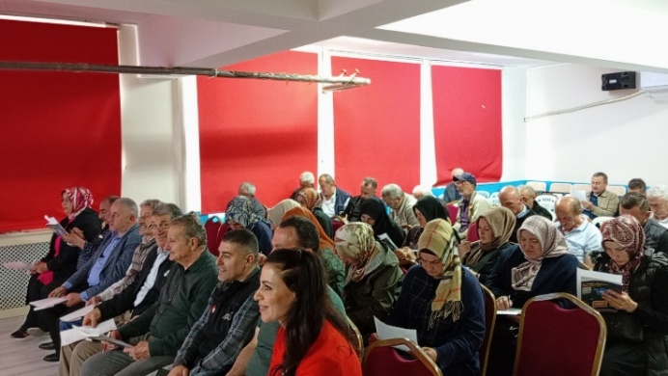
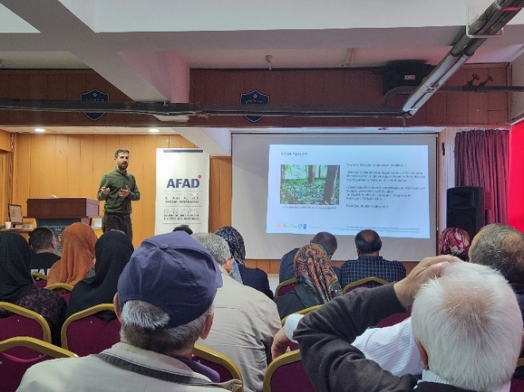

The General Directorate of Combating Desertification and Erosion, affiliated with the Ministry of Environment, Urbanization and Climate Change, signed the Rio Synergy Protocol with the Ministry of Agriculture and Forestry on 17 June 2025, as part of the ‘World Day to Combat Desertification and Drought” events. The ceremony was attended by approximately 100 participants, including senior officials and staff from both ministries, members of the press, and representatives of political parties. Prior to the signing, Fatma Varank, Deputy Minister of the MoEUCC, delivered a presentation on Turkey’s National Strategy and Action Plan for Combating Desertification, highlighting the activities carried out by the General Directorate of Combating Desertification and Erosion within the framework of this plan. Additionally, she provided detailed information regarding the DOKSAY Project.

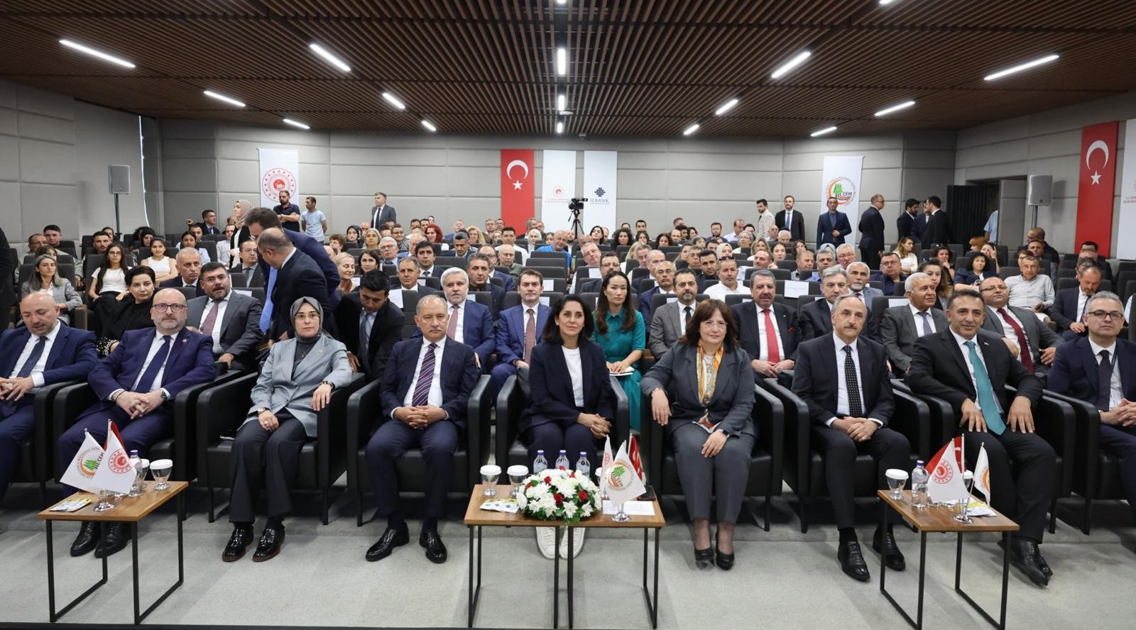

A press release was prepared to announce the Inception Workshop and the project to the local and national public and was sent to the press after obtaining the views and approval of ÇEM and UNDP. The news was published on the websites of the Ministry of Environment, Urbanization and Climate Change (ÇEM), the Rize Governorship, and in the local press.

An interview about the project, including statements from the ÇEM project coordinators, the General Director, and the mukhtar of Kireçhane Neighborhood, was given to Anadolu Agency. This interview was published in both national and local media.

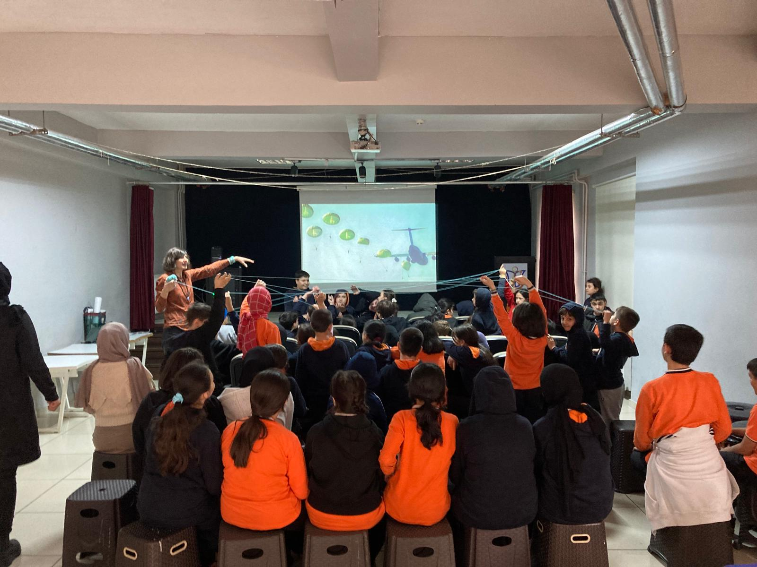

Within the scope of this plan and related activities, an official letter was sent by ÇEM to the Ministry of National Education. The letter requested the facilitation of primary school students’ visits to the Taşkın Museum in Trabzon, the provision of education on biodiversity and land degradation to students in nine primary and secondary schools within the project area, and the raising of awareness on Sustainable Land Management (SLM) for adults at Public Education Centers. Within this framework, training was provided to 610 children from nine primary and secondary schools between 24–26 December.

As part of the trainings, the school administrations were also consulted regarding the organization of visits to the Taşkın Museum for students. The school administrations expressed their willingness to cooperate on this matter. For this activity, initially planned to be held in May, companies in Rize were researched and preliminary price inquiries were conducted to prepare a draft budget to ensure the safe travel of the students. Additionally, as part of the planning activities for this visit, the Taşkın Museum in Trabzon was visited to obtain information on the duration of the informational activities at the museum and the participant capacity.

It was also agreed with the Provincial Directorate of National Education to conduct educational and awareness-raising activities for adults on the importance of sustainable land use in Rize and its districts. On 22 December, the Deputy General Director of the General Directorate of Combating Desertification and Erosion (ÇEM), the Chairman of the DKM Board of Directors, the Provincial Director of Environment, Urbanization, and Climate Change, and the Project Coordinator visited the Rize Provincial Director of National Education to discuss and evaluate the established cooperation.

Activity 3.1.5. Undertake end-of-project seminar to share project lessons (2027-Q3)
Status: To be initiated

Component 4: Monitoring and Evaluation
Output 4.1: Monitoring and evaluating project impacts and environmental, social and gender safeguards
Activity 4.1.1. Conduct of an inception workshop (From 2025-Q1 to 2025-Q2)
Status: Completed
On 15 April 2025, the Inception Workshop was held in Rize, with a total of 101 participants representing 24 institutions, including central and local government agencies, universities, and international organizations. Of these participants, 35% were women and 66% were men.

Activity 4.1.2. Track changes in the three global indicators – land cover (assessed as LCC), land productivity (assessed as NPP), and carbon stocks (assessed as SOC) (From 2025-Q2 to 2027-Q3)
Status: Ongoing
Based on the evaluations of ÇEM experts and the following feedback received from participants during the Inception Workshop, monitoring activities for land cover and land productivity are being carried out within the scope of this activity.

“- The CORINE Land Cover (CLC) dataset is a widely used land cover monitoring product in many studies and national monitoring systems in Türkiye, including the LDN Decision Support System. However, it is updated only every six years, so annual tracking is not possible. To overcome this, the use of UASIS data produced by ÇEM could be considered; however, this could still be challenging.
- Land productivity, assessed as NPP, can be tracked using MODIS NPP products or derived from NDVI. Nevertheless, it should be noted that annual monitoring is possible but should be interpreted over a longer time series in order to identify trends.
- Annual monitoring of soil organic carbon (SOC) is not worthwhile since SOC changes slowly and results can only be observed optimally after 10 years. In this sense, the project duration is too short for SOC monitoring/tracking.”
Activity 4.1.3. Collect data to track indicators (From 2025-Q2 to 2027-Q3)
Status: Ongoing
Data collection activities are being carried out to monitor the number of direct beneficiaries, disaggregated by gender, as a co-benefit of the GEF investment. Within this scope, individuals interviewed during institutional consultations and field visits are recorded and disaggregated by gender.

Activity 4.1.4. Implement a gender mainstreaming action plan (From 2025-Q2 to 2027-Q3)
Status: Ongoing
GSA 1: In order to map stakeholders with the capacity to reach and represent women in the region (including cooperatives, women’s cooperatives, and NGOs), consultations were held with the Salarha Municipality. It was determined that the most effective way to reach women in the villages was through the village headmen, and this method has been implemented. Women’s cooperatives in Rize were also researched.

GSA 3: Within the scope of Activity 1.3.2. research for this activity has begun through the survey prepared under Activity 1.3.2 to identify viable methods and channels to reach women farmers, older farmers, and youth in the region. Examine the outreach capacities of the main institutions. The Kaçkar’ın Etekleri Women’s Entrepreneurship and Production Cooperative was visited and informed about the project. Within the scope of this meeting, information was also obtained regarding the cooperative’s activities and the challenges encountered in carrying out these activities.

GSA 6: A stakeholder communication strategy with gender and age sensitivity has been prepared.

GSA 7: During the field studies, women farmers were visited to gather their opinions on local disasters and traditional land use practices.

GSA 8: A survey was prepared to determine the socio-economic structure of disadvantaged groups living in the project area, their social and roles in tea cultivation, perspectives on tea farming and land use, educational needs, and the communication tools they use. The first implementation of this survey was conducted on 3-4 September with 13 women aged 36-82 living in Kireçhane Neighborhood. The communication approach during the field studies was designed based on the information obtained about social roles in the project area. In this context, to ensure that participants felt comfortable and engaged in the survey, the implementation was carried out by the Field Coordinator/Project Manager (who is female).

GSA 10: Interviews were conducted with women in the Kireçhane neighborhood regarding traditional land use. In this context, information was obtained about the traditional drainage system called “kehriz,” which was formerly used in tea gardens but is no longer in practice. Additionally, information was gathered about the traditional culture that developed in line with the region’s climate and geography.

Activity 4.1.5. Monitor social and environmental risks and implement associated safeguards management plans (From 2025-Q2 to 2027-Q3)
Status: To be initiated

Activity 4.1.6. Carry out an independent terminal evaluation (2027-Q3)
Status: To be initiated

Contribution to Gender Equality
The project aims to create an environment that helps overcome gender biases, promotes the empowerment of women, and supports inclusion and equal opportunities. Therefore, in line with the revised Gender Action Plan, special efforts are being made to ensure that gender considerations are fully integrated into project implementation.
The project’s communication activities and field implementations are carried out within the framework of the Gender Action Plan (The work carried out so far contributes to Activities 1, 3, 6, 7, 8 and 10 of the Gender Action Plan).
A survey study was prepared with the support of a volunteer expert to assess the current situation regarding gender equality in the project area. During the preparation phase of this study, a literature review was conducted. It was decided that the interviews, particularly those aimed at increasing women's participation, would be carried out by the Project’s Field Coordinator (woman). A Terms of Reference (ToR) has been prepared for the engagement of an expert to conduct gender equality-related activities in the later phases of the project. The necessary procurement procedures are being followed, and it is planned to hire an expert for this purpose in the upcoming period.

Monitoring Arrangements
Constituting of Project Board: The first Project Steering Committee meeting was held on 22 July 2025 at the General Directorate of Combating Desertification and Erosion (ÇEM). The Steering Committee has approved the project’s budget and activity plan for 2025. It has been decided that the next meeting will be held in January 2026.
Inception report: The Inception Workshop was organized on April 15, 2025 to raise awareness among stakeholders about the project's objectives and to determine the individual roles and responsibilities of stakeholders in the project planning, implementation and monitoring processes.
Standard UNDP monitoring and reporting requirements as outlined in the Initiation Plan: Within the scope of UNDP Türkiye's monitoring and evaluation plan, UNDP quality assurance requirements, quarterly risk management and evaluation requirements are carried out under the coordination of UNDP Türkiye.
Quarterly Progress Reports: The year 2025 includes four progress reports. Through these reports, the project’s progress and financial activities for each quarter have been submitted to UNDP Türkiye.
Evaluation meetings: ÇEM and DKM have conducted progress monitoring and evaluation meetings for the implementation of the project. These meetings were held primarily at the ÇEM office, with online sessions conducted when necessary.
Follow up meetings: In line with the decision to hold regular progress follow-up meetings between ÇEM, UNDP Türkiye and DKM during the second quarter, a meeting was held online on 25 September. During the meeting, the current status of the project, challenges encountered, and potential solutions were discussed.
Project Implementation Report (PIR): The first PIR report for the project will be prepared to cover the period from 1 June 2025 to 30 July 2026. The Project Implementation Report will be prepared by DKM and uploaded to the system by ÇEM following final revisions.

Financial Status
 | 2025 |  |  |  | Total
 | Q1 | Q2 | Q3 | Q4
Currency | 35,770 | 39,109 | 40,583 | 41,800
USD Requested | $18.540,00 | $40.653,00 | $58.179,82 | $127.442,06 | $244.814,88
TL Requested | ₺663.175,80 | ₺1.589.898,18 | ₺2.361.111,64 | ₺5.349.507,91 | ₺9.963.693,52
TL Cleared | ₺663.175,80 | ₺600.725,91 | ₺1.328.562,76 | ₺4.197.600,00 | ₺6.790.064,47
USD Cleared | $18.540,00 | $25.292,70 | $32.736,93 | $100.000,00 | $176.569,63

The financial reporting process for the 4th quarter of the project is ongoing. Therefore, the cleared amount presented in the table for the 4th quarter, and consequently the annual expenditure amounts, are draft figures.

